

**Web Security – IE2062**

**Assignment**

**Hilton Domain**



**Table of Contents**

**Acknowledgment** 3

**Hilton** 5

**In scope** 5

**subdomains** 6

• Sublist3r 6

• Recon-ng 10

• Subfinder 17

• Crt.sh 20

**Findings The alive subdomain** 21

• httprobe 21

**Emails gathering** 23

• theHarvester 23

• Infoga 29

• Sherlock tool 31

**Identifying Website Technologies** 36

• Builtwith.com 36

• Web tech 38

• Whatweb tool 39

• wappalyzer 39

• w3Techs 40

**DNS Enumeration** 43

• nmap 43

• DNSEnum 45

• DNSRecon 49

**Public Device Enumeration** 50

• Censys 50

**Finding Achieved Information** 55

• Way Back Machine 55

• waybackurls 56

**Find the Structure of the File System** 58

• dirsearch 58

• UrlBuster 64

**Server Fingerprinting** 70

• whatweb 70

• wafw00f – to find firewalls 72

**Conclusion** 75

**References** 76

# **Acknowledgment**

Before I start writing my assignment, I'd like to sincerely thank Dr. Lakmal Rupasinghe, the lecturer in charge, for his guidance and help in getting our entire class started on and completing our assignments.

I also want to convey my sincere gratitude to Ms. Chethana Liyanapathirana for the guidance and constant support she gave me and the rest of our class as we worked to complete this task.

# **Hilton**

## **In scope**

* **\*.hilton.com**
* **\*.hilton.com.tr**
* **\*.hilton.io**
* **\*.hiltonbusinessonline.com**
* **\*.hiltonjapan.co.jp**
* **\*.hiltonmanage.com**
* **hilton.com**
* **hilton.com.tr**
* **hilton.io**
* **hiltonbusinessonline.com**
* **hiltonhawaiianvillage.jp**
* **hiltonjapan.co.jp**
* **hiltonlocalbiz.com**
* **hiltonmanage.com** [1]

# **subdomains**

## Sublist3r

Sublist3r depends on the requests, dnspython, and argparse Python modules, thus we must now check for dependencies. The requirements.txt file may be used to install these dependencies:

pip install -r requirements.txt

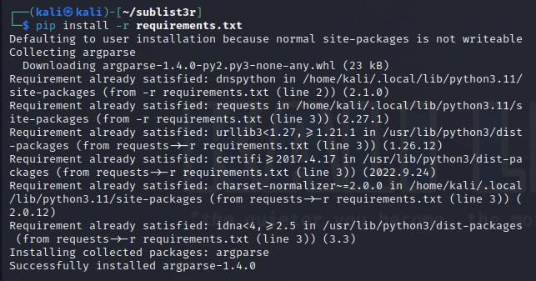

All necessary modules may even be installed manually.

**Request module**

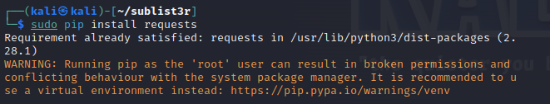

**dnspython module**

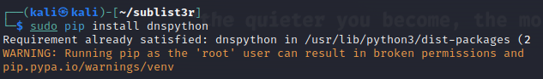

**Argparse module**

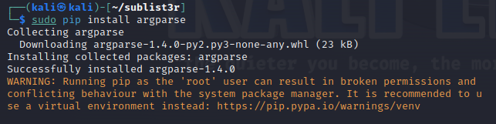

To run the tool,

./sublist3r.py

When using a tool, if you encounter any errors such as "dns.resolver module not found" or "dns.message module not found," it's possible that you are using Python version 2.7 while the dnspython module is installed in Python version 3. Therefore, it would be preferable if you used Python pip rather than pip3 to resolve these errors.

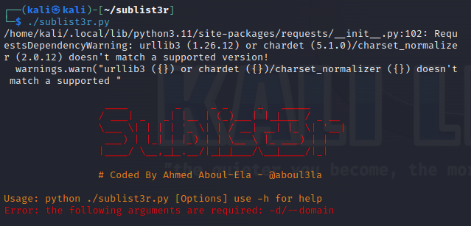

Now that our tool only operates in the current directory and requires us to enter the directory each time we want to execute it, we will create a symbolic link to enable us to access it from any directory.

sudo ln -sfv /opt/Sublist3r/sublist3r.py /usr/bin/sublist3r

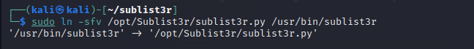

 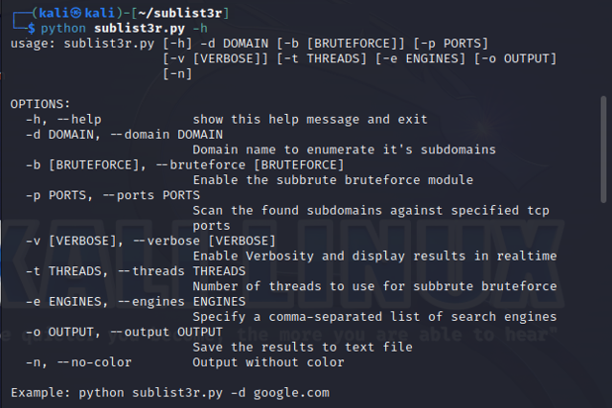

To list the subdomains

sublist3r -v -d kali.org -t 5 -e bing -o ~/Desktop/subresult.txt

Where -v will verbose the output and indicate where it is receiving the results, and -d stands for domain listing. The number of threads will be 5, and Bing will be used as the search engine. The retrieve results will be recorded in a subresult.txt file in the desktop directory.

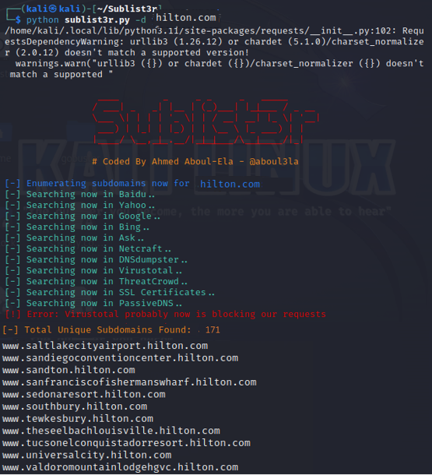

As you can see, the query makes it simple for us to seek a website's subdomains by listing all the domains and subdomains connected to hilton.com [2].

## Recon-ng

You will be welcomed by recon-ng's splash screen as seen below when it launches.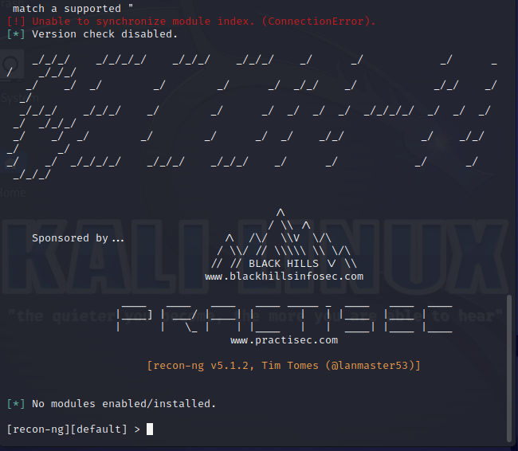

Next, let's input help at the recon-ng prompt to learn what commands we may use.

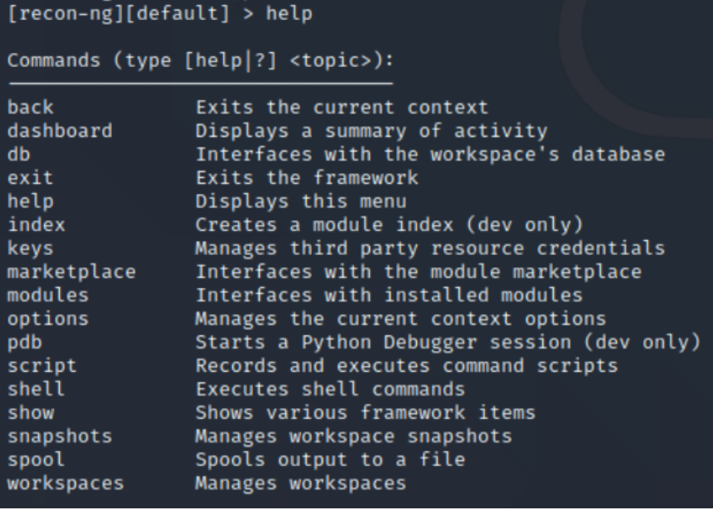

You will recognize many of the same commands, like use, set, display, search, etc., if you have used Metasploit.

Simply type "search marketplace" in recon-ng to see all the modules.

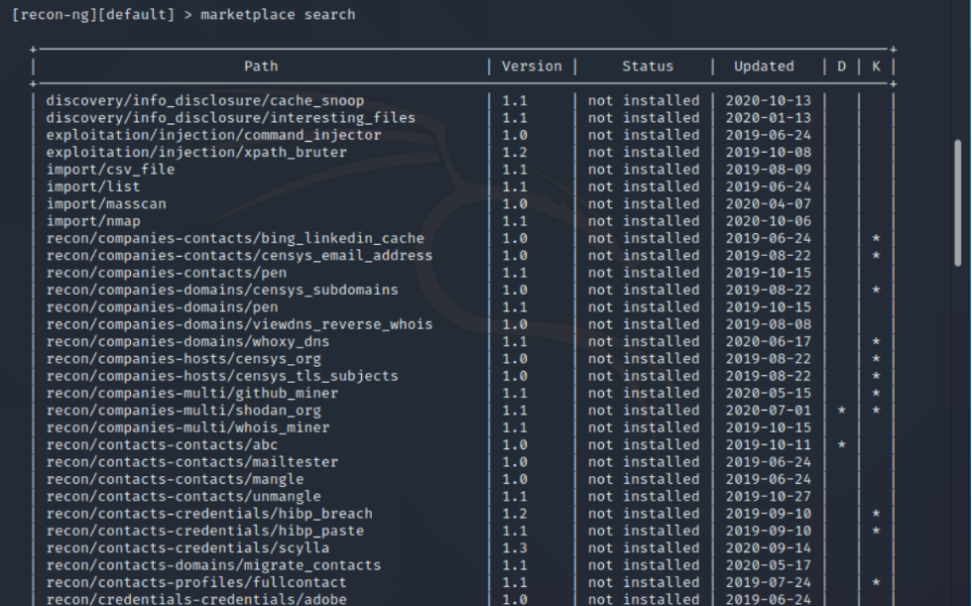

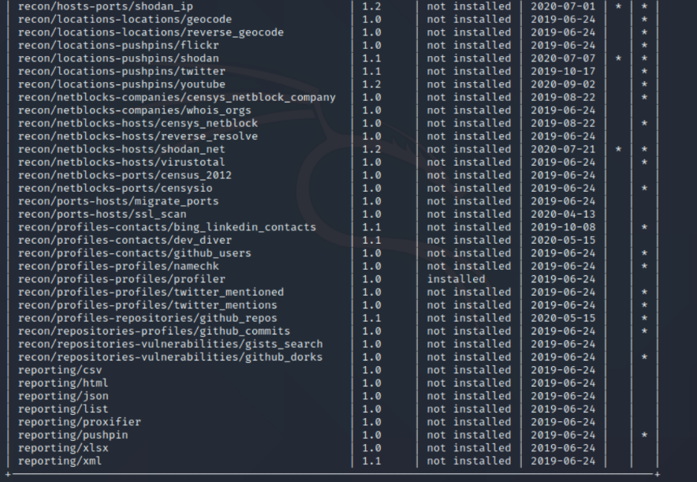

Utilizing websites like Facebook, Twitter, Instagram, Google, Bing, LinkedIn, and others is possible with recon-ng. You only need to get an API key and input it to access these sites.

Therefore, to utilize Shodan for reconnaissance after obtaining our Shodan API key, we only need to add that key.

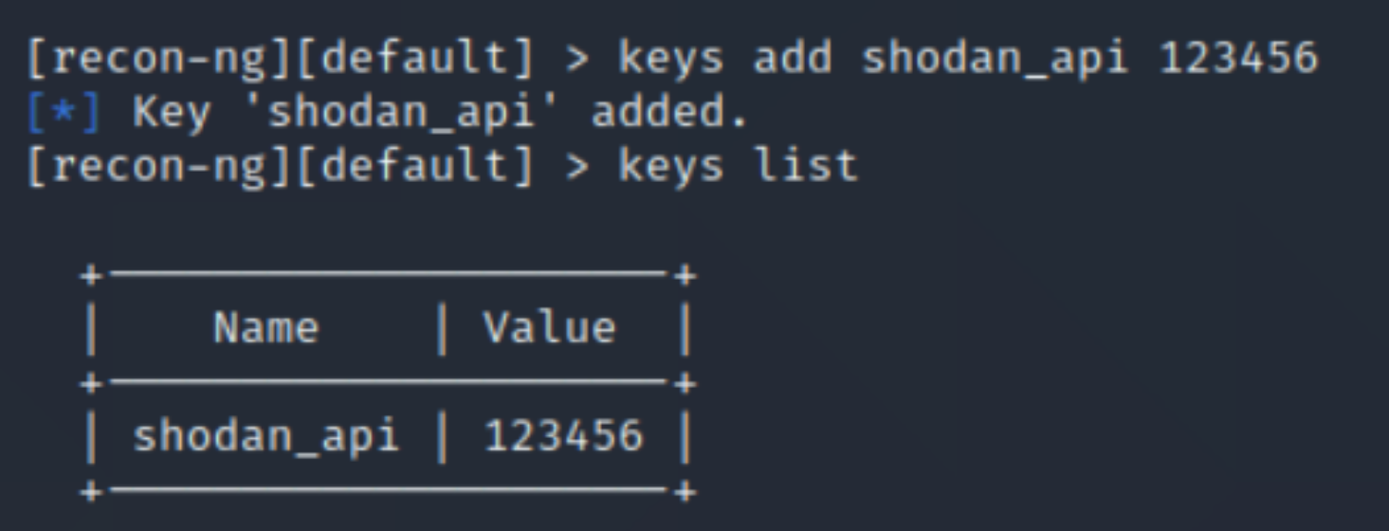

There are several modules in recon-ng for locating information that is online. Here, let's focus on the profiler module alone.

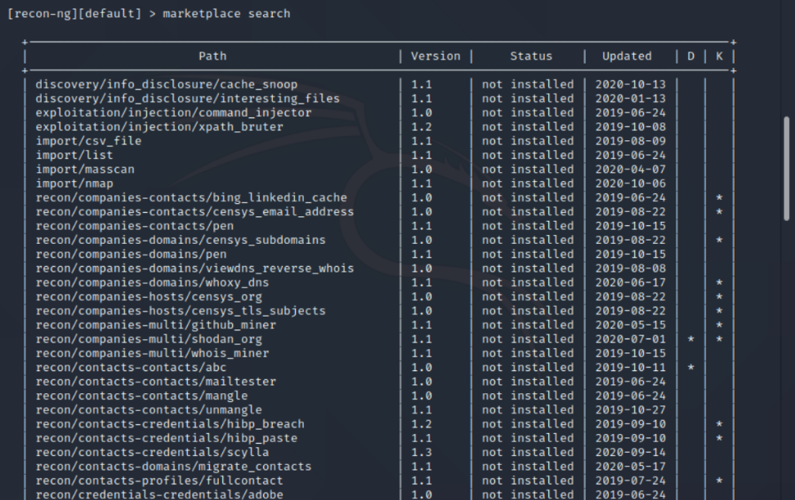

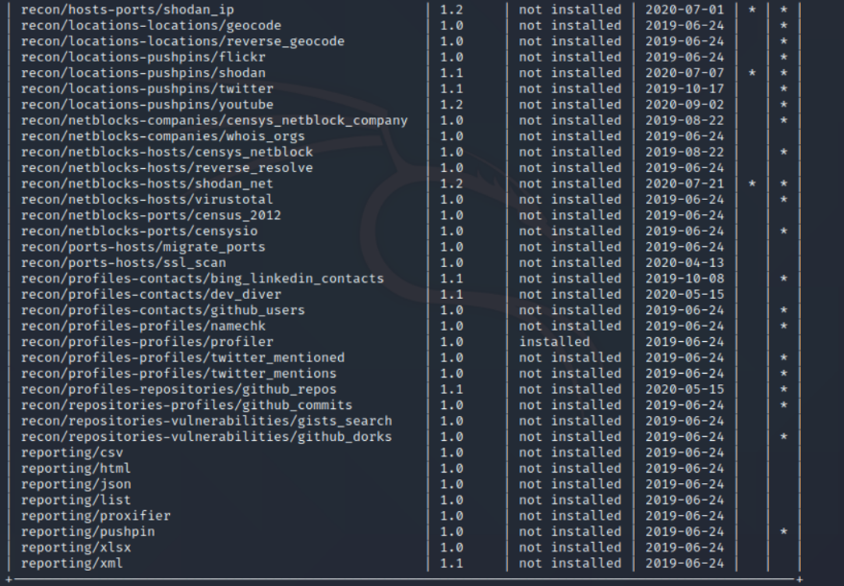

Assume for the moment that you are looking for someone who goes by the profile name and want to see if they have the same profile on any other websites. For that, recon-ng offers a module!

It is known as the "profiler" and is available in the recon-ng market. just enter to install this module;

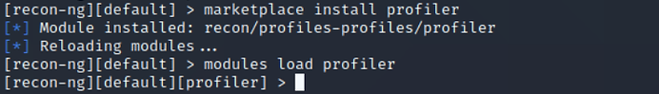

for additional information about this module.

****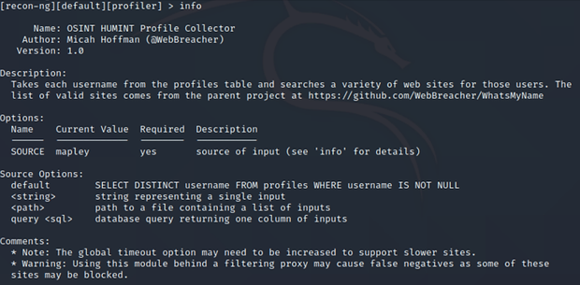

As seen in the screenshot up above, it uses a profile name and looks up profiles with that name on a variety of websites.

We just enter the profile we're looking for to start our search.



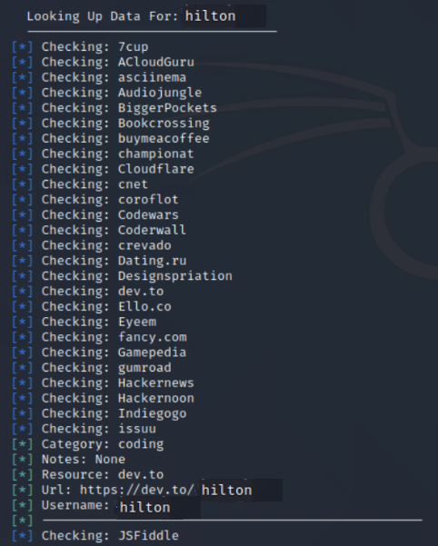

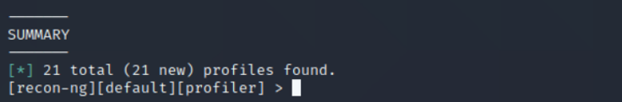

The profiler module then looks for matches for this profile name across a variety of websites. It discovered 21 matches in this instance! Despite having the same profile name, these could not all be the same individual, it should be noted [3].

## Subfinder

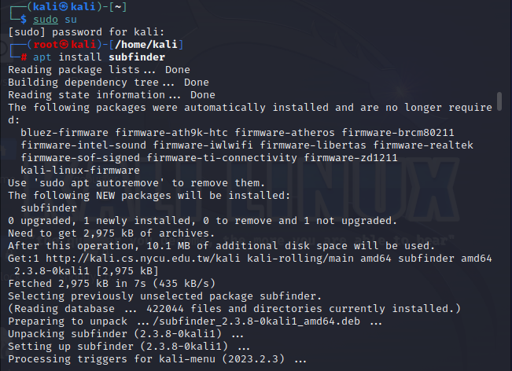

After the installation is complete, use the following command to view all the capabilities of the program. 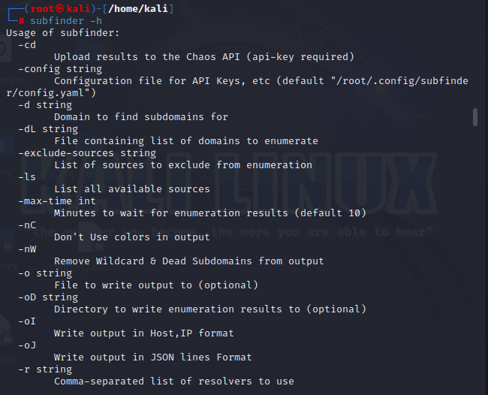

It is now time to determine whether it is operating flawlessly. Giving the name of the domain you wish to search is all that is necessary. All the results will be shown on the terminal after the command has been run [4].

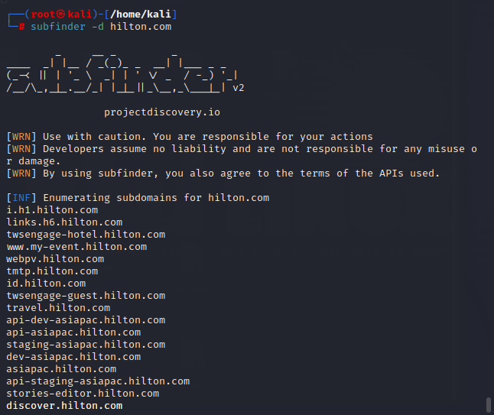

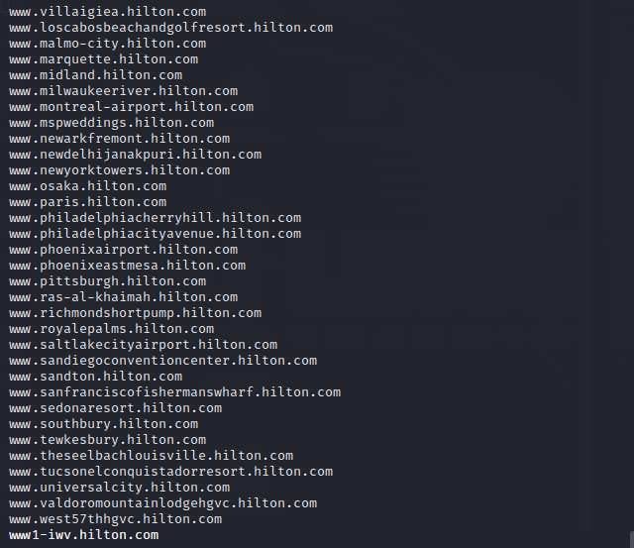

## Crt.sh

Firstly, install the crt.sh.

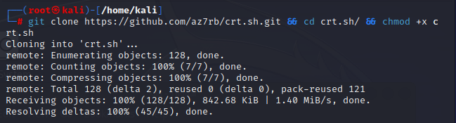

You have successfully downloaded crt.sh [5].

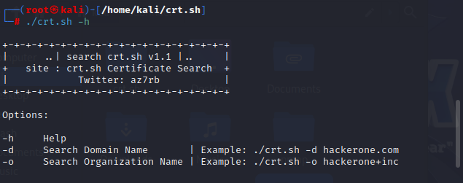

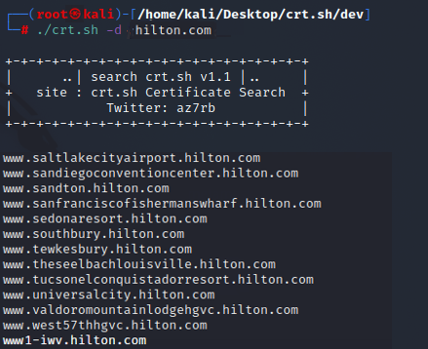

# **Findings The alive subdomain**

## httprobe

You must have Golang set up. Read my article on how to install Golang on Kali Linux if you've never used it before and need assistance getting started. Download 'httprobe' by executing.

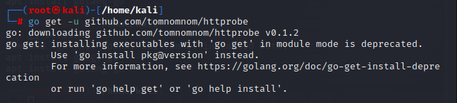

You must print out your domains and pipe them to httprobe to utilize it. The example below shows how to read data from domains.txt using cat and send the results to httprobe.

By default, httprobe probes port 80 for http and port 443 for https. The '-p' argument can be used to add additional ports.

The '-s' argument causes the default ports to be disregarded.

Using the '-t' argument, you may define a custom timeout if you anticipate a lengthy response time from the destination server. The configured time is in milliseconds.

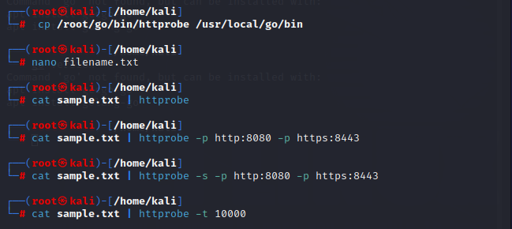

'httprobe' can be used in conjunction with other programs like 'assetfinder'. If you are unfamiliar with assetfinder, you may read my prior post for assistance in getting started [6].

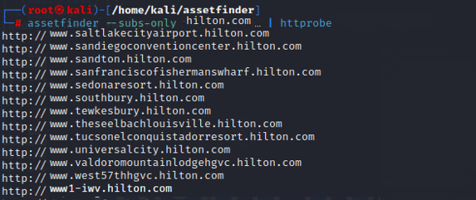

# **Emails gathering**

## theHarvester

In this essay, I'll discuss email harvesting using Kali Linux's theharvester email harvester.

It is an integrated utility, so you don't need to worry about installing it, and you can use the Harvester program by running a short command in the terminal.

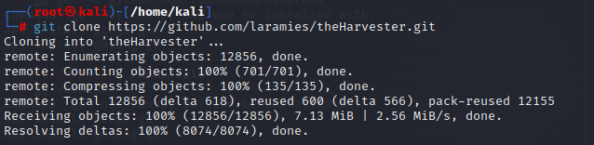

It comes pre-installed in almost all versions of Kali. Download it from the repository if not. Please take note of the lowercase "h" in the repository name.

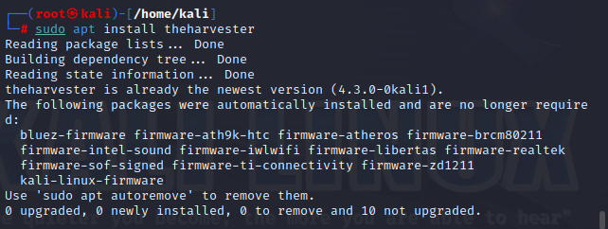

Let's start by looking at the Harvester's help screen.

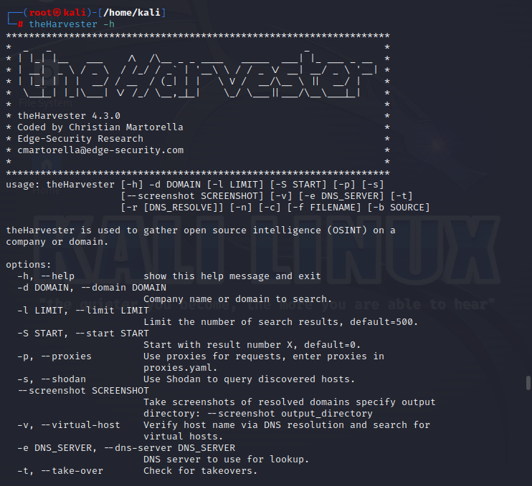

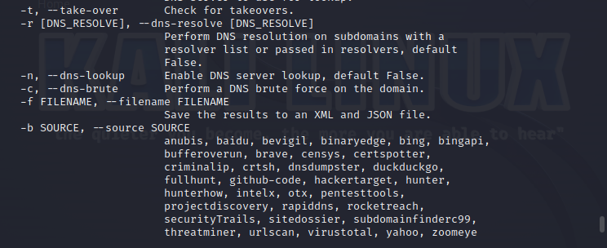

The syntax is pretty simple, as you can see in the first screen above.

Let's try utilizing theHarvester to combat everyone's preferred photo-sharing app, Snapchat. We can run the following command to scrape all of this information from Hilton [7].

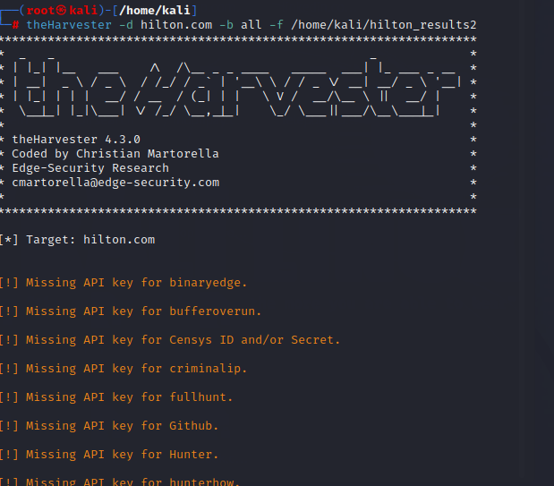

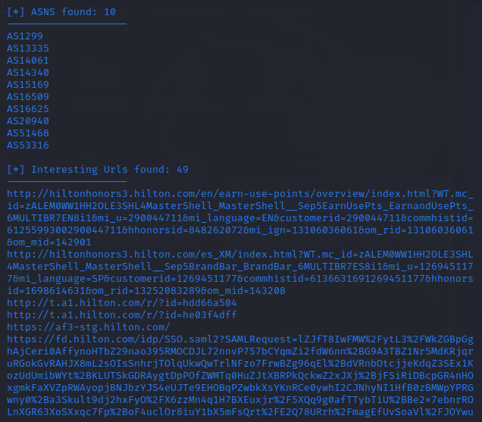

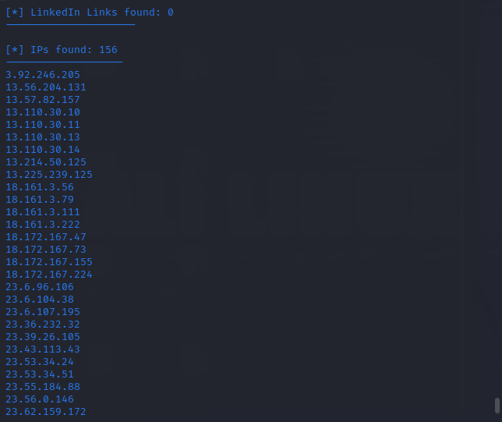

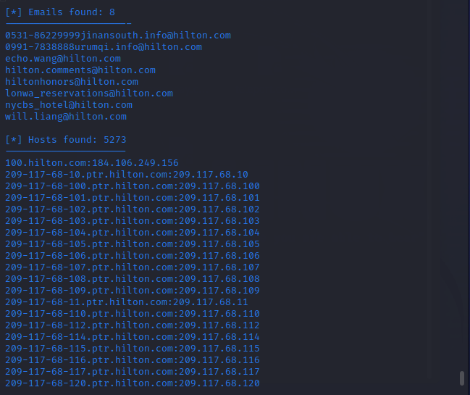

## Infoga

Use the following command to launch your Kali Linux operating system and install the program.

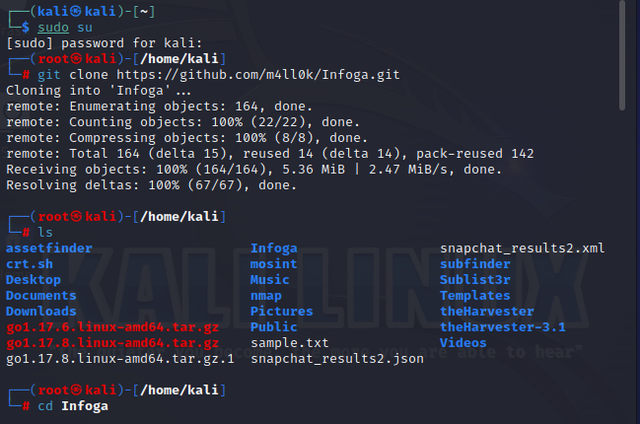

Use the next steps to install the tool's setup.

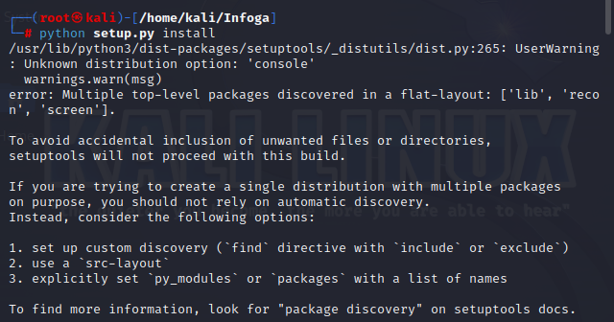

Use the following command to launch the utility after it has been downloaded to your computer [8].

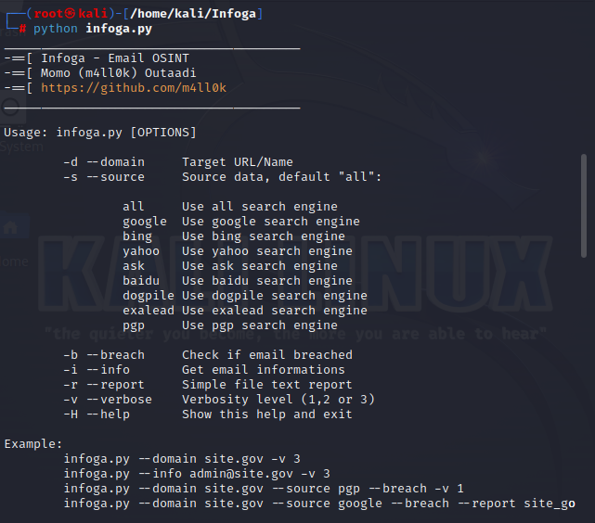

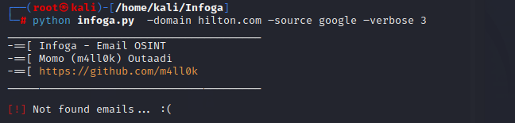

## Sherlock tool

The following command will open your Kali Linux and transport you to the desktop.



Use the command below to create a new directory here named Sherlock while you are on your desktop.



Make a move to the newly formed directory by using the following command.



Now that you are in the Sherlock directory, use the following command to install the utility. You must use the following command to clone the tool from GitHub into this directory.

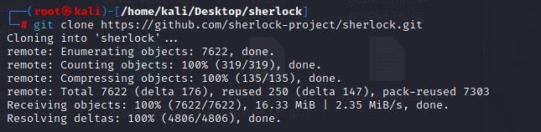

The directory holds the tool that has been downloaded. Use the following command to list the contents of it.

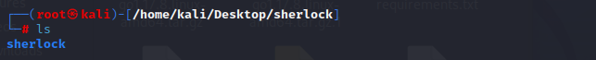

As you can see, the tool has a new directory. To go to this directory, use the following command.



Use the following command to list the tool's contents.

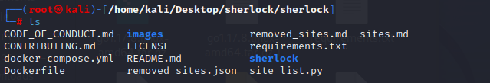

Use the following command to install the prerequisites right now. The utility won't work if the prerequisites aren't installed.

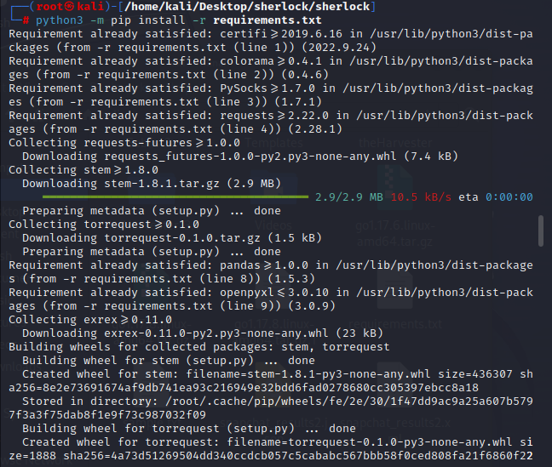

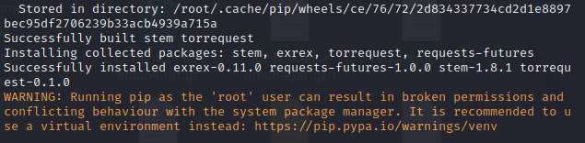

It's time to launch and test the program now that all the prerequisites have been downloaded. Utilize the following command to test the tool. The tool's help index will be opened using this command.

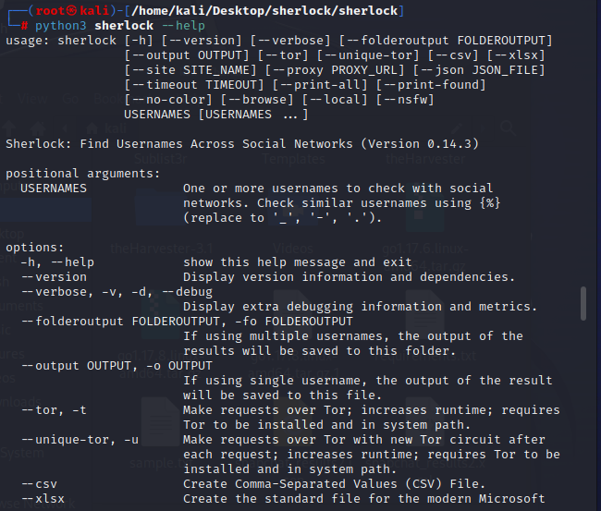

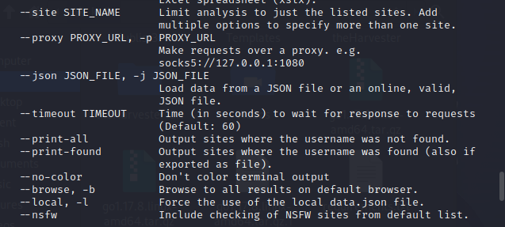

The program has been downloaded and is functioning properly. Now, you can look up Facebook [9].

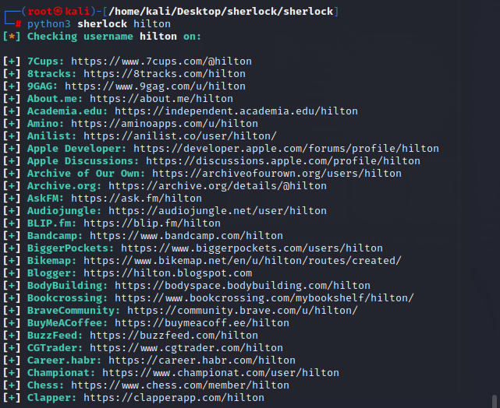

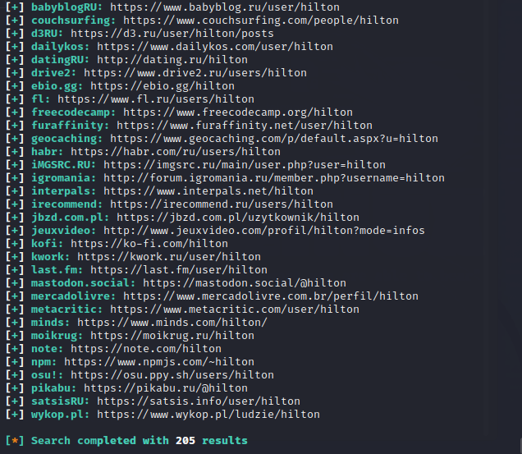

# **Identifying Website Technologies**

* Builtwith.com [10]

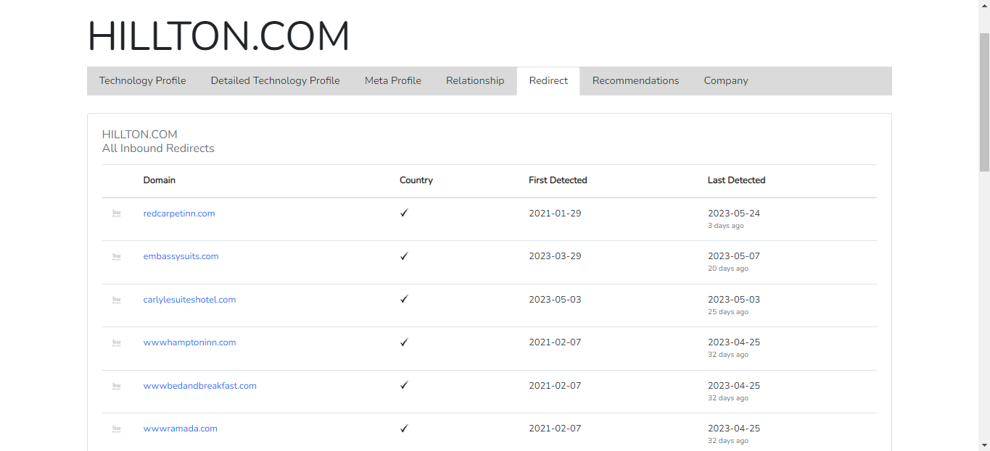

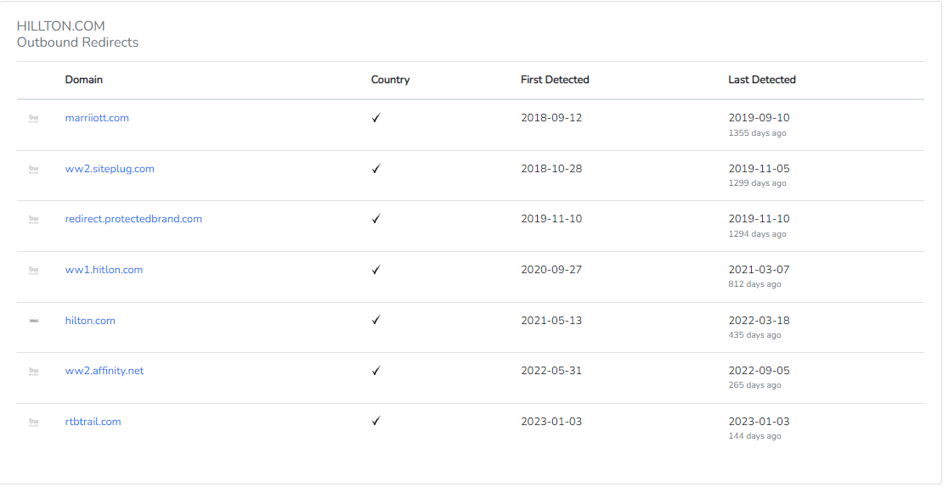

* Web tech [11]

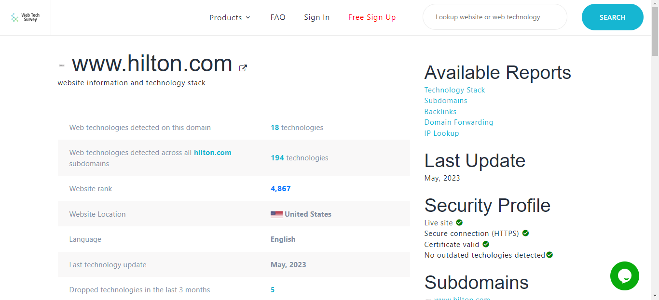

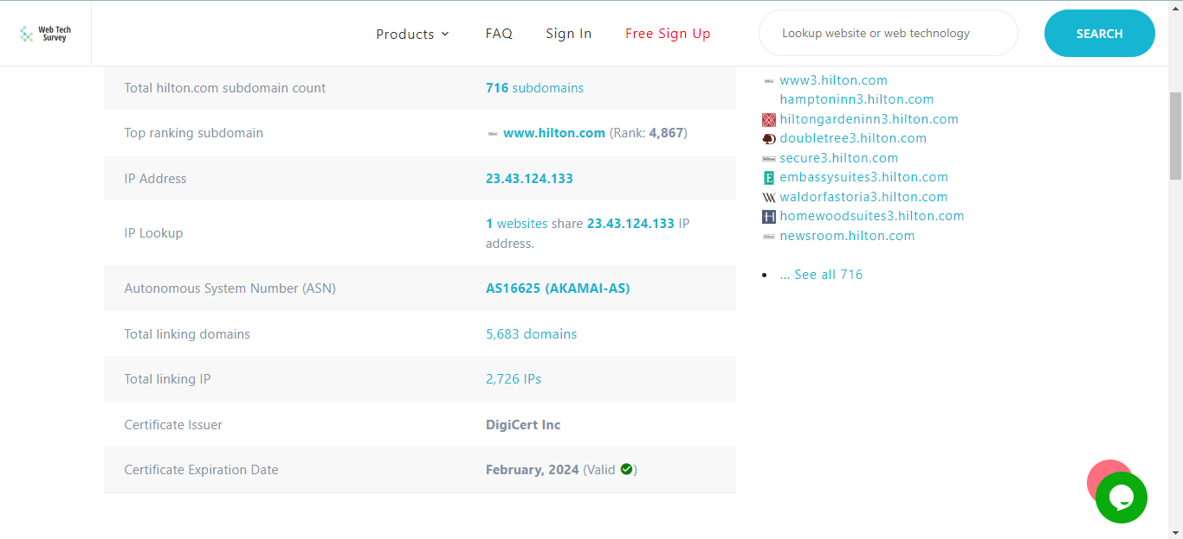

* Whatweb tool [12]

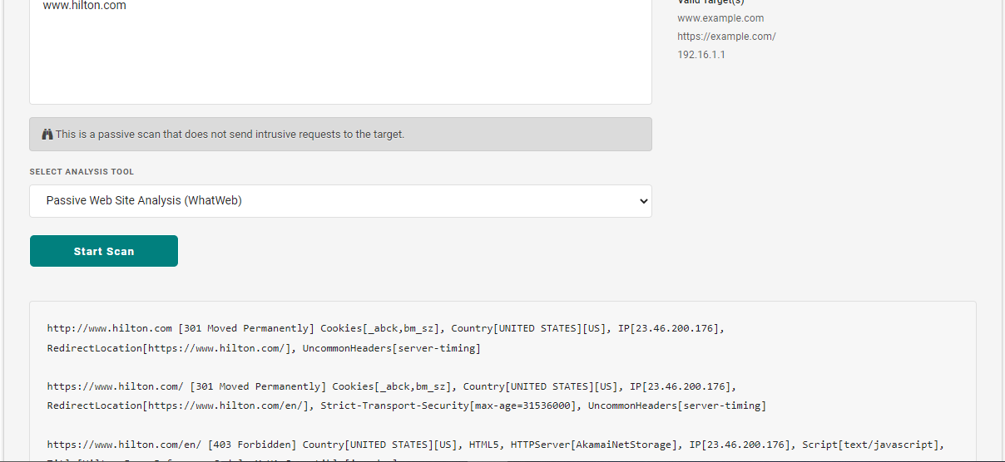

## wappalyzer

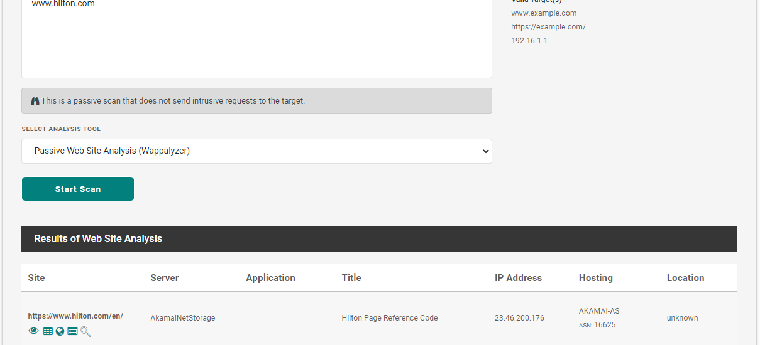

* w3Techs [13]

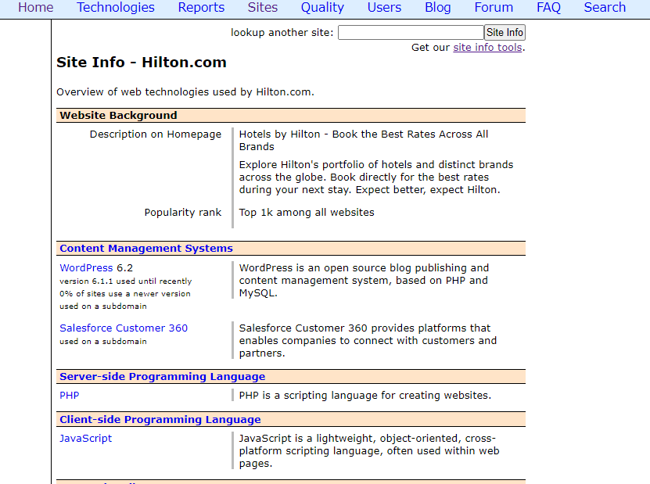

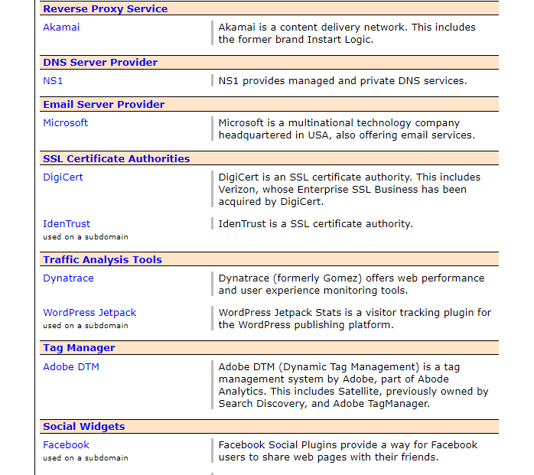

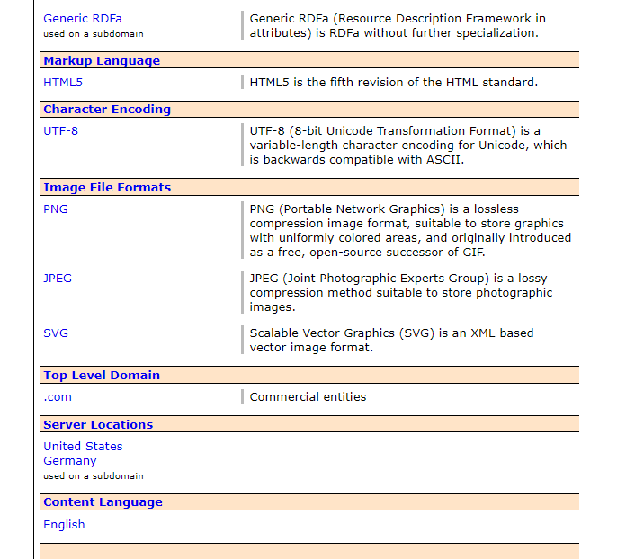

# **DNS Enumeration**

## nmap

Using the DNS Service Discovery protocol, the ensuing program will attempt to identify the services offered by hosts. It issues a multicast DNS-SD query and gathers every reply.

To obtain a list of services, the script first makes a query to _services._dns-sd._udp.local. It then sends a follow-up question to each one to elicit further data.

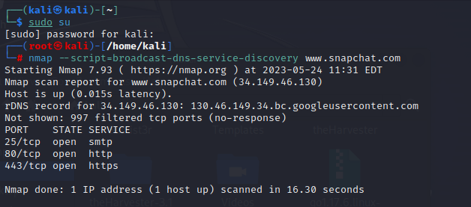

The next command will use popular subdomains as a starting point to attempt and enumerate DNS hostnames. Dns-brute will also attempt to enumerate popular DNS SRV entries when given the dns-brute.srv parameter.

For IPv4 and IPv6, respectively, wildcard records are specified as "*A" and "*AAAA" [14].

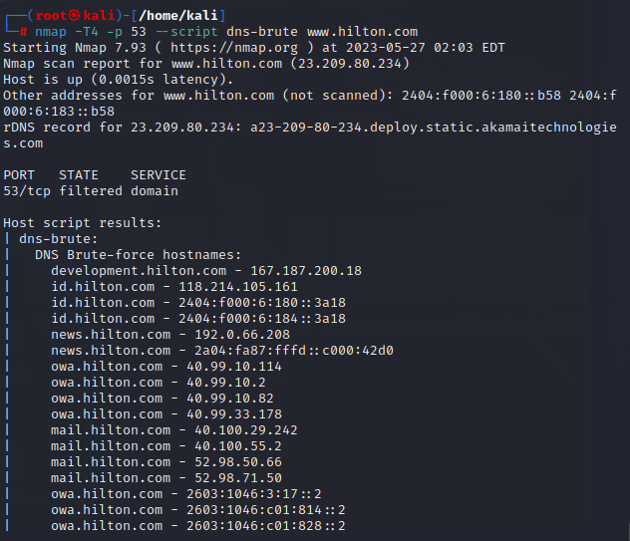

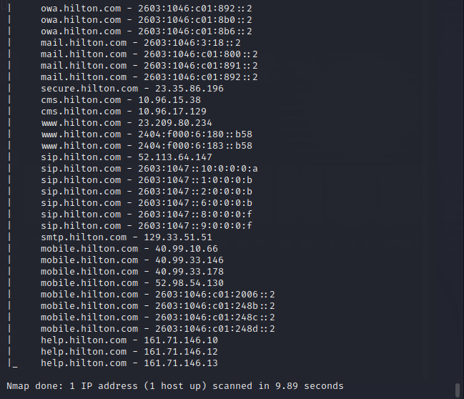

## DNSEnum

a multi-threaded Perl script to find non-contiguous IP blocks and list a domain's DNS records.

The next command will prevent reverse lookup enumeration and store the output result in XML format [15].

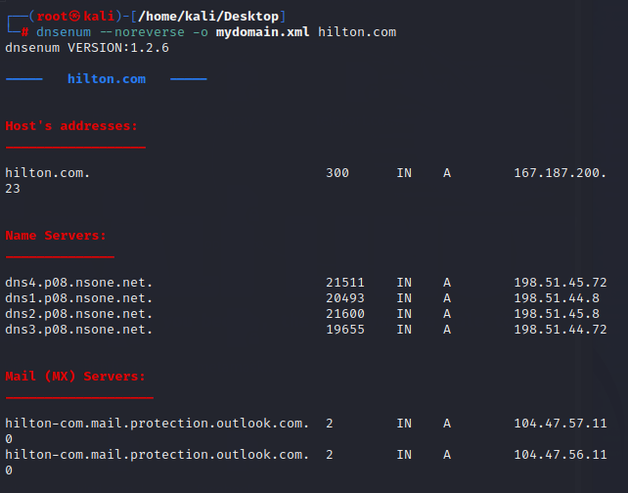

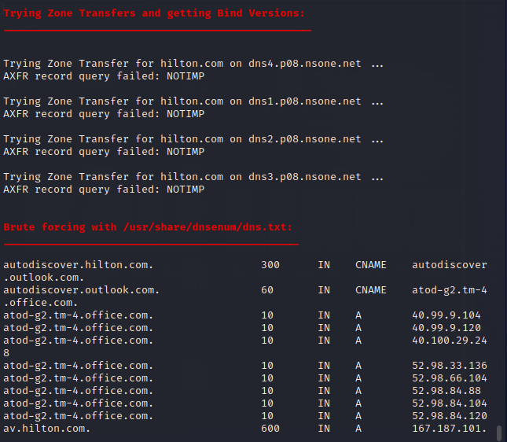

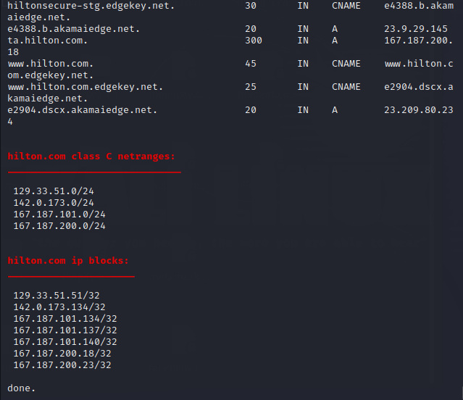

## DNSRecon

DNSRecon allows users to check for zone transfers in all NS records, list all General DNS Records (MX, SOA, NS, A, AAAA, SPF, and TXT), enumerate common SRV records, expand top-level domains (TLDs), brute force check for wildcard resolution, look for PTR Records, search for A, AAAA, and CNAME Records in a DNS server's cache, and enumerate frequently used DNS records on the local network. Google can be used to count hosts and subdomains [16].

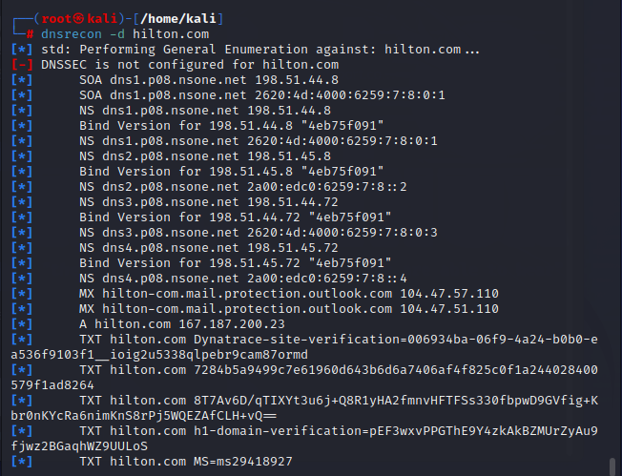

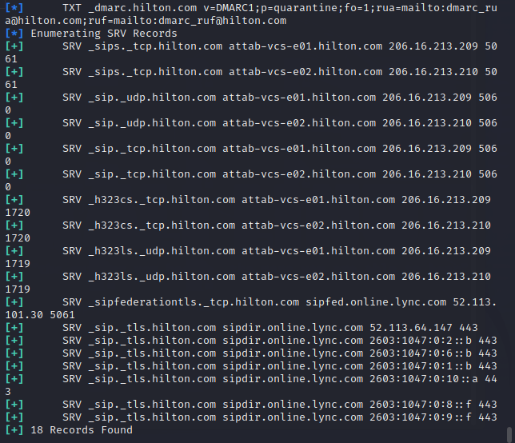

# **Public Device Enumeration**

## Censys

Firstly, install the censys subdomain finder.

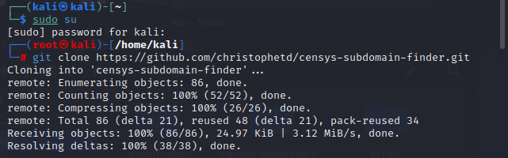

Then I install the dependencies.

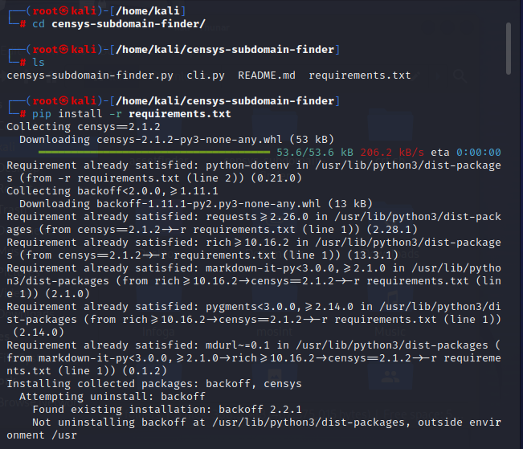

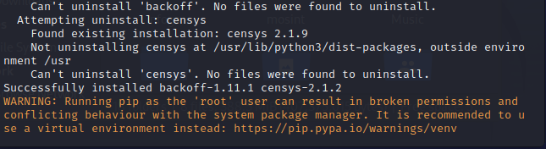

Then I registered the censys account and Go to https://censys.io/account and enter your API secret and ID into two environment variables.

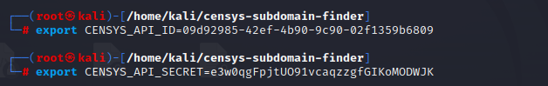

After that, I found usage of censys-subdomain-finder.py.

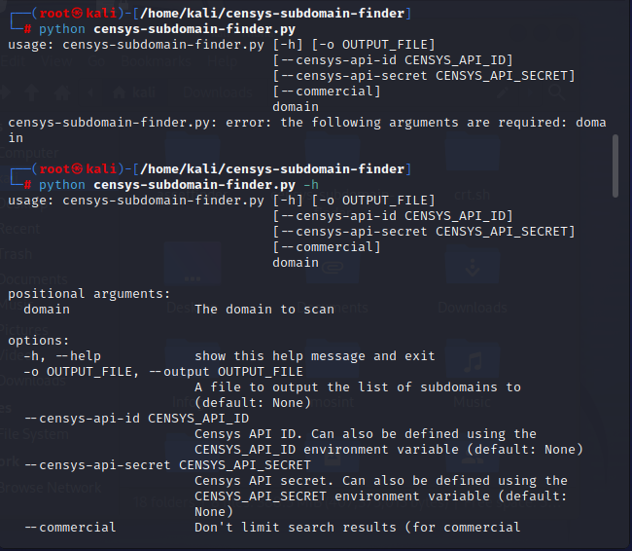

There are lots of subdomains here [17].

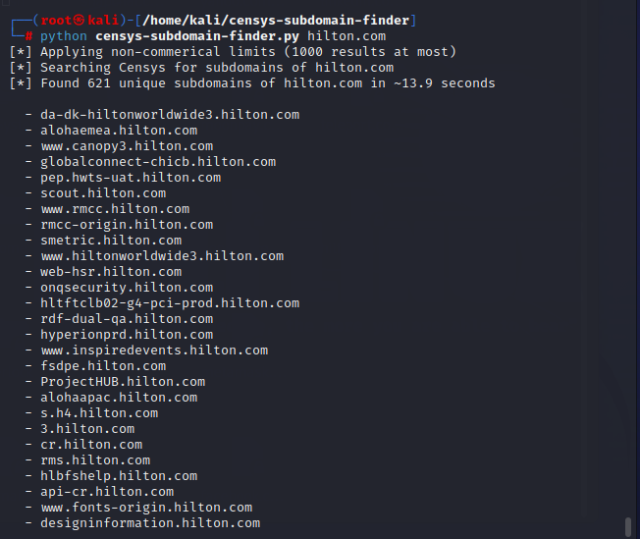

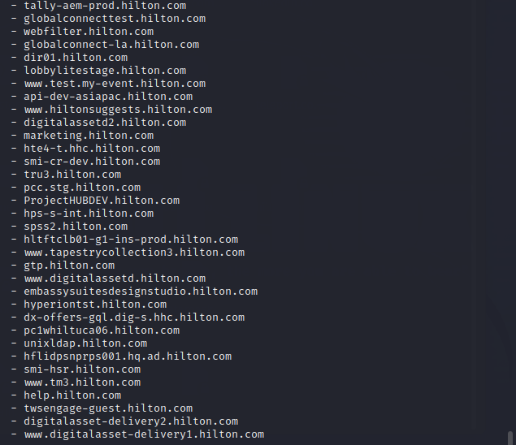

# **Finding Achieved Information**

## Way Back Machine

This an online site that can find archived information such as archived versions of websites, when it was upgraded, etc.

Website link: - <https://archive.org/web/>

This is how the Way back Machine appears.

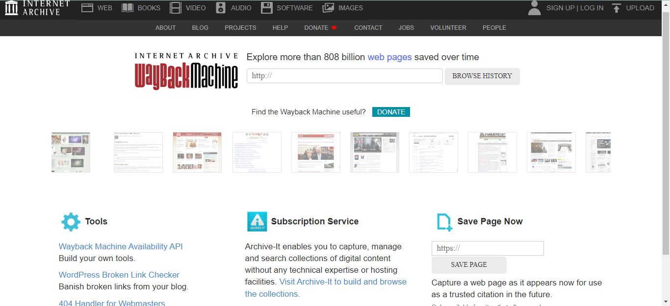

Now I type the targeted domain.

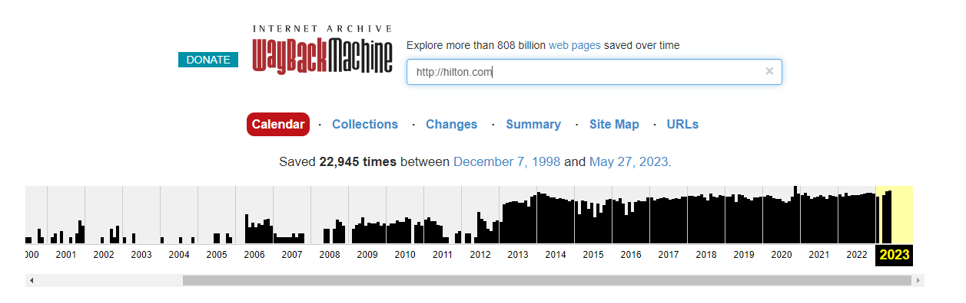

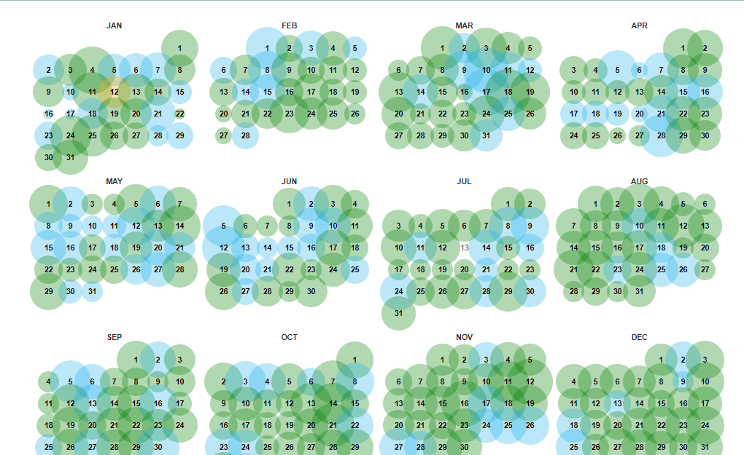

The number of times the Way Back Machine crawled snapchat.com is represented in this calendar view [18].

## waybackurls

You must install the Go utility on your system to use this program; otherwise, it will not work. Let's quickly install it with the next command. I already installed it.

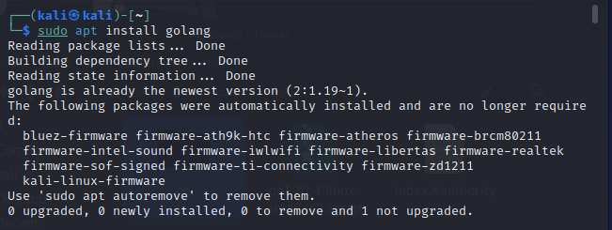

Once the installation is complete, we may use the Go utility to download and use this program from anywhere.

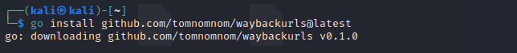

Now you can see it.

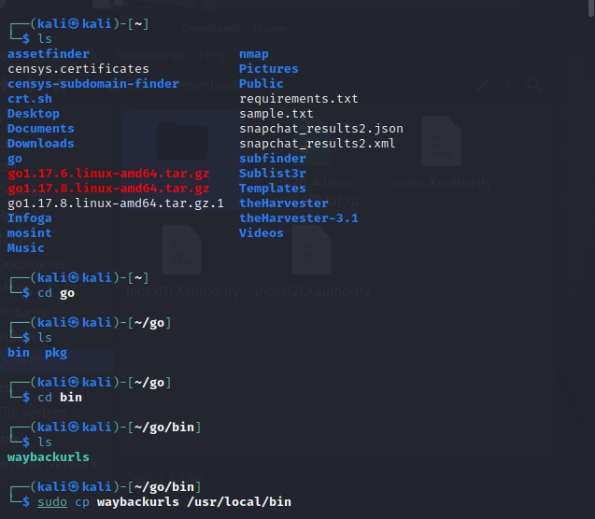

Then I found usage of waybackurls.

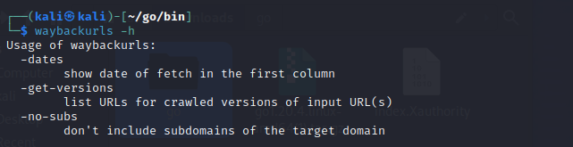

It's time to test this tool because everything appears to be in order. All we have to do is provide the target URL we want to crawl in the command. With the use of sitemaps, it will automatically crawl all the web application's URLs and documents [19].

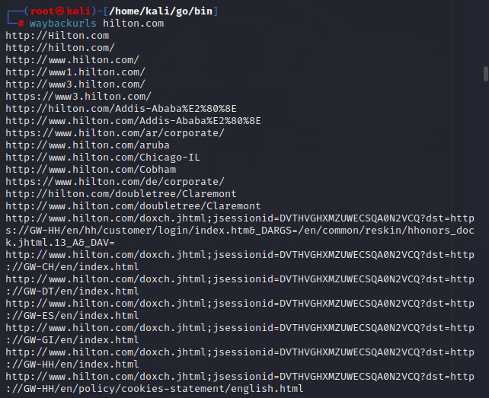

# **Find the Structure of the File System**

## dirsearch

Use the following command to launch your Kali Linux terminal and go to the desktop.



Now that you are on your desktop, use the following command to create a new directory named Dirsearch. We'll finish installing the Dirsearch utility in this directory.

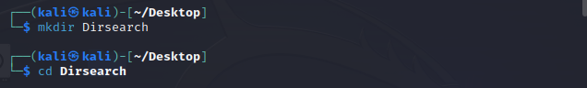

Installing the tool is the next step. The tool must be copied from Github.

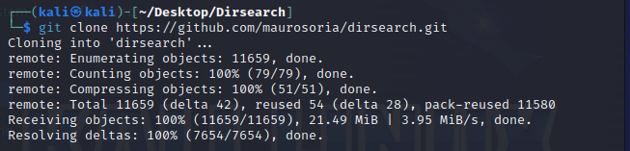

The dirsearch directory has successfully received the tool's download. Now use the command below to list the tool's contents.



You can see that when we were installing the utility, a brand-new directory for the dirsearch tool was built.Now use the command below to go to that directory:



Use the next command to get the necessary packages for executing the utility.

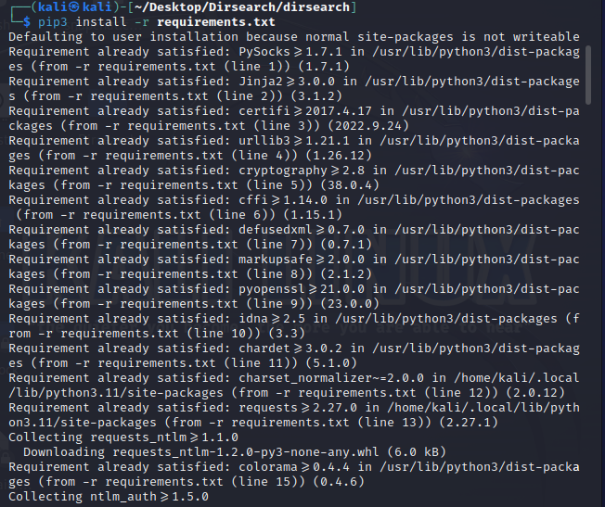

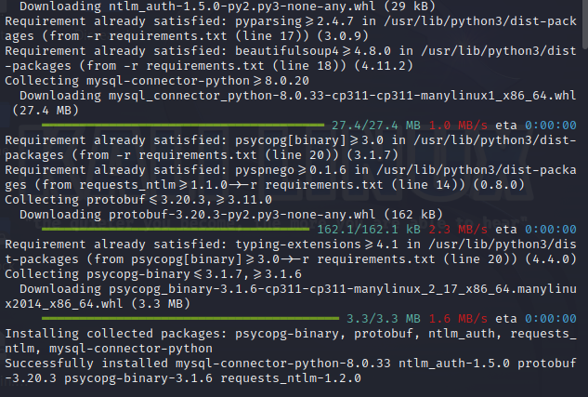

Now that the installation is complete, use the command below to examine the tool's help index, which provides a better understanding of the program [20].

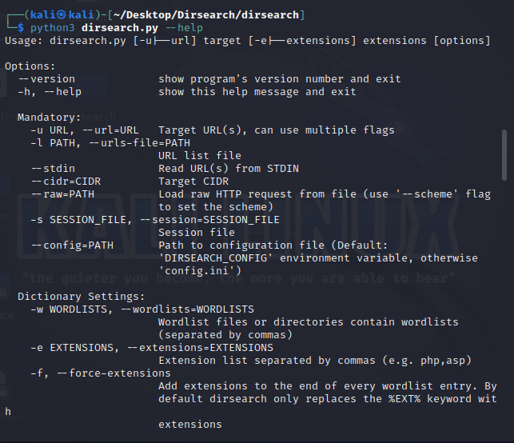

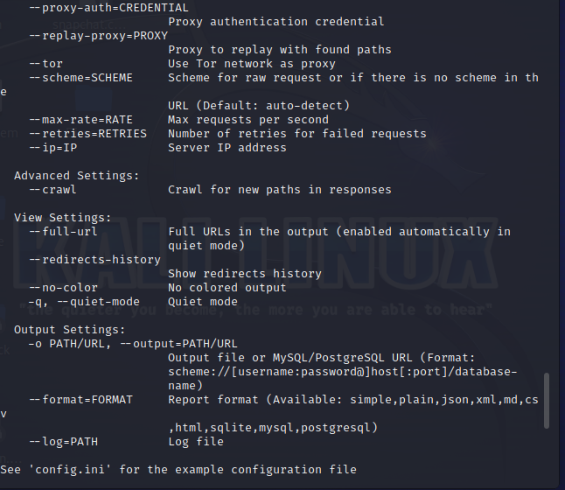

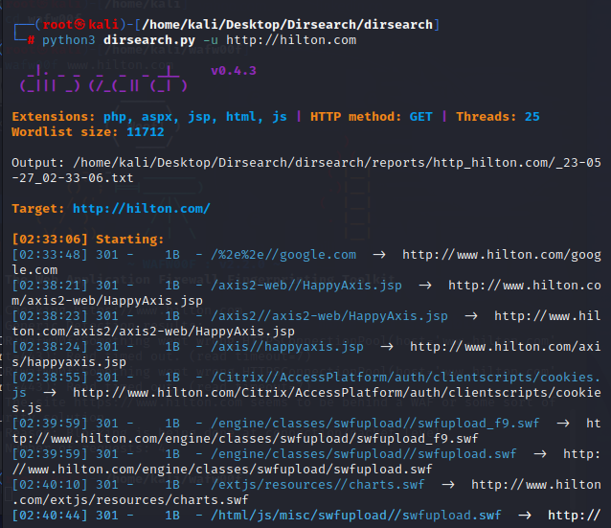

## UrlBuster

Use the following command to see if the Python environment is established or not.

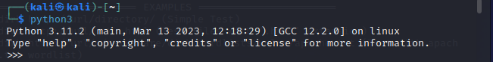

Use the following command to install the Tool using Pip.

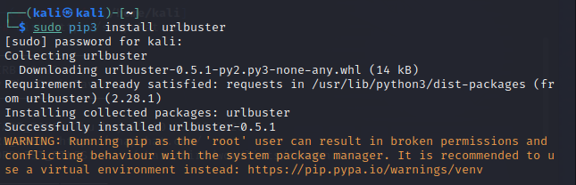

Use the following command to view the tool's help file.

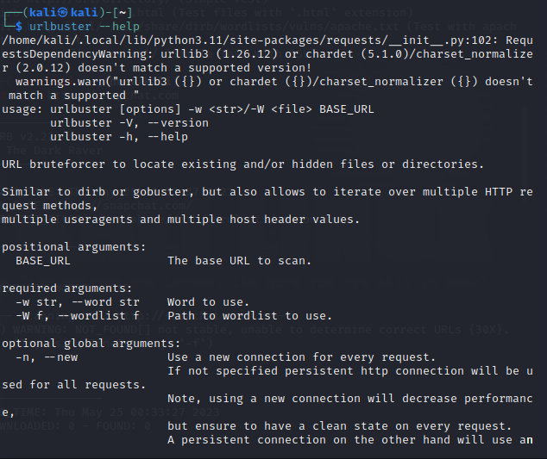

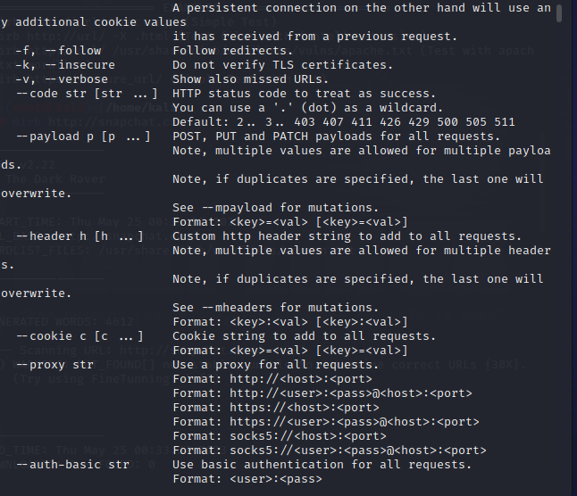

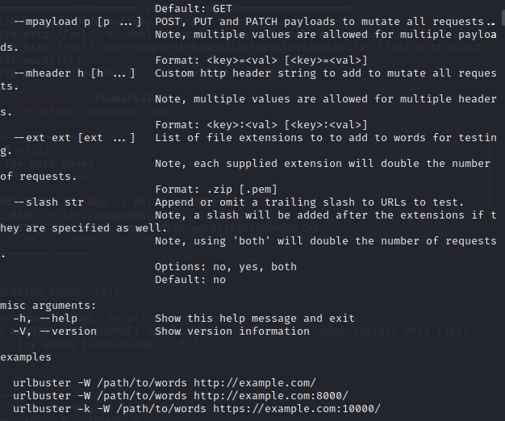

By using brute force, we will fuzze directories. Using the -W tag, we have supplied the word list [21].

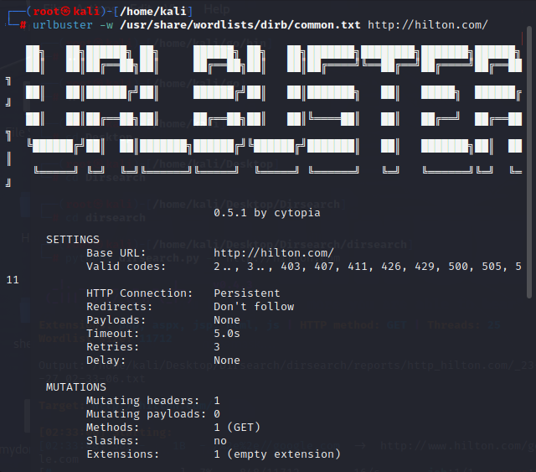

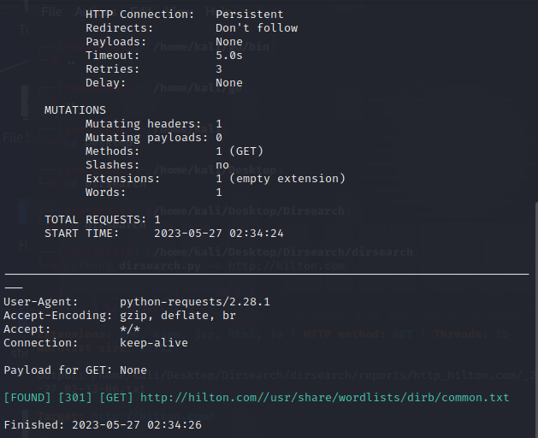

# **Server Fingerprinting**

## whatweb

Whatweb should be entered in the Kali Linux terminal.

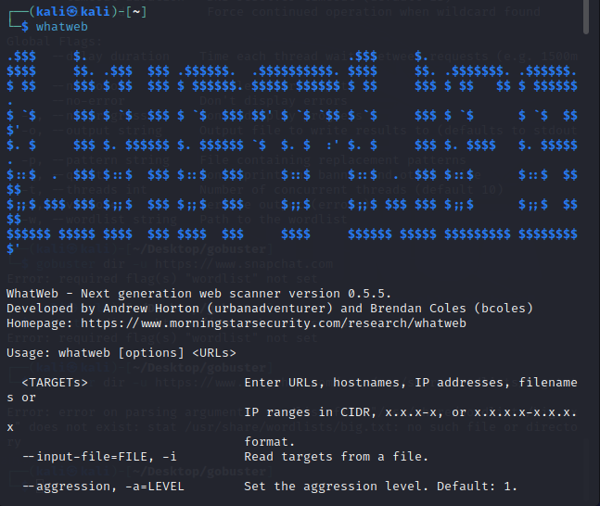

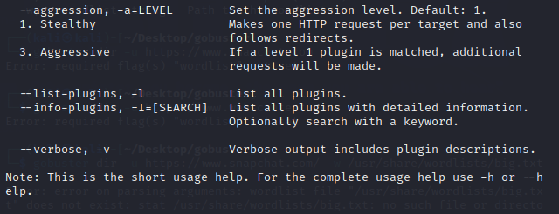

Now, in step two, enter the command to learn more about your target [22].

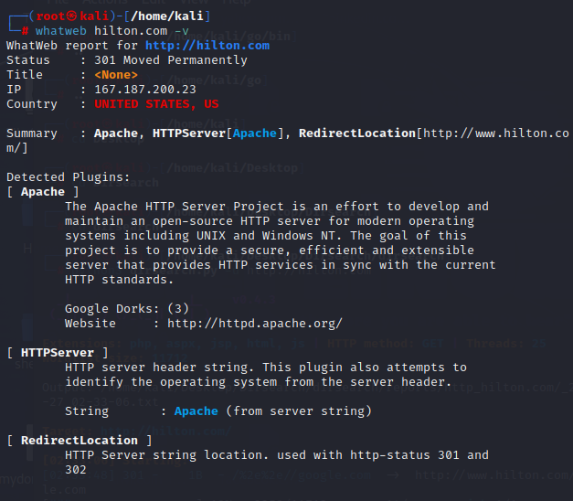

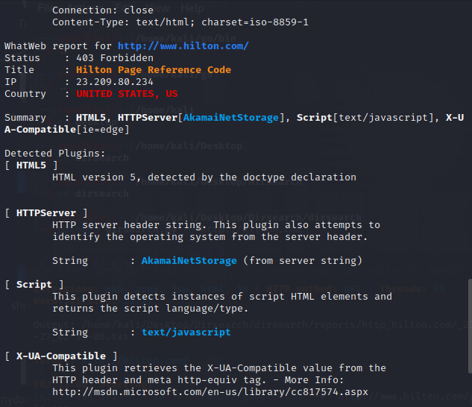

## wafw00f – to find firewalls

Use the following command to launch your Kali Linux operating system and install the program.

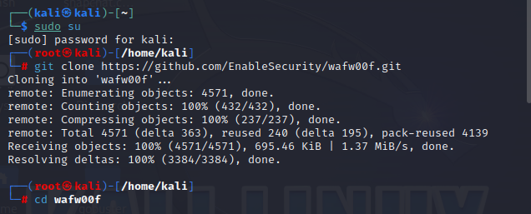

One has downloaded the tool. Give the tool the go-ahead to execute now.



Run the tool by entering the following command.

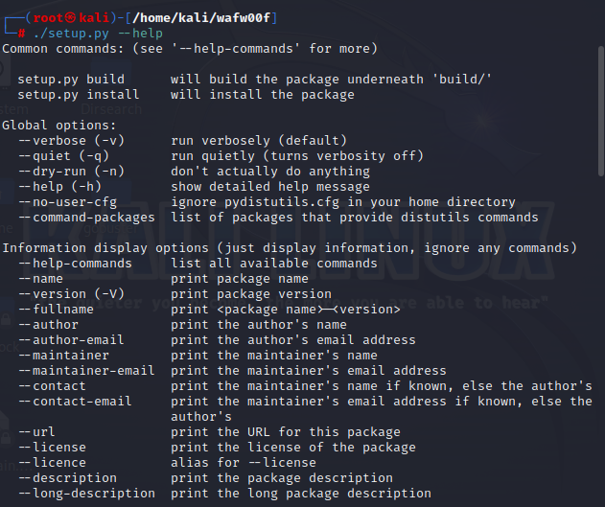

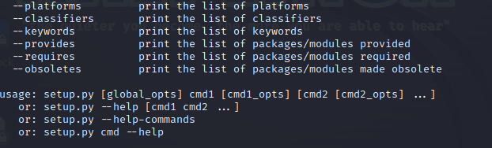

The tool is currently operating correctly. Examples of the tool in use will be shown.

To determine if firewall protection is concealed behind a domain or not, use the wafw00f utility [23].

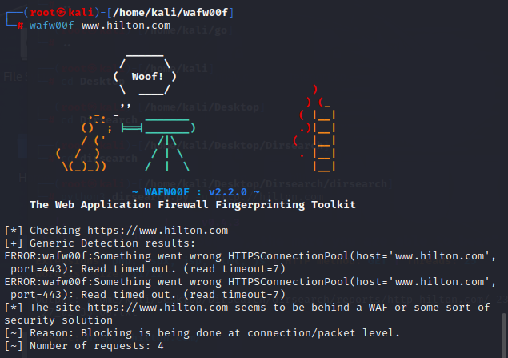

# **Conclusion**

This assignment has revealed the flaws in the [Hilton](https://www.hilton.com/) site System, which is part of the HackerOne Bug Bounty Program. High, medium, and legal vulnerabilities are divided into categories according to how serious they are under critical. I also described every tool I used for each sentence.

# **References**

|  |  |
| --- | --- |
| [1] | "hackerone," *hackerone.com.* |
| [2] | "sublist3r," *https://github.com/aboul3la/Sublist3r.* |
| [3] | "recon-ng," *https://github.com/lanmaster53/recon-ng.* |
| [4] | "subfinder," *"subfinder," https://github.com/projectdiscovery/subfinder.* |
| [5] | "crt.sh," *https://github.com/vavarachen/crtsh_scanner..* |
| [6] | "httprobe," *https://github.com/tomnomnom/httprobe.* |
| [7] | "theHarvester," *https://github.com/laramies/theHarvester.* |
| [8] | "infoga," *https://github.com/m4ll0k/Infoga.* |
| [9] | "sherlock," *https://github.com/sherlock-project/sherlock.* |
| [10] | "builtwith," *https://pro.builtwith.com/.* |
| [11] | "webtech," *https://webtechsurvey.com/.* |
| [12] | "WhatWeb & Wappalyzer Scan," *https://hackertarget.com/whatweb-scan/.* |
| [13] | "w3techs," *https://w3techs.com/sites.* |
| [14] | "nmap," *https://nmap.org/.* |
| [15] | "DNSEnum," *https://github.com/fwaeytens/dnsenum.* |
| [16] | "DNSRecon," *https://github.com/darkoperator/dnsrecon.* |
| [17] | "censys," *https://search.censys.io/api.* |
| [18] | "way back machine," *https://archive.org/web/.* |
| [19] | "waybackurls," *https://github.com/tomnomnom/waybackurls.* |
| [20] | "dirsearch," *https://github.com/maurosoria/dirsearch.* |
| [21] | "urlbuster," *https://github.com/cytopia/urlbuster.* |
| [22] | "what web," *https://github.com/urbanadventurer/WhatWeb.* |
| [23] | "wafw00f," *https://github.com/EnableSecurity/wafw00f.* |